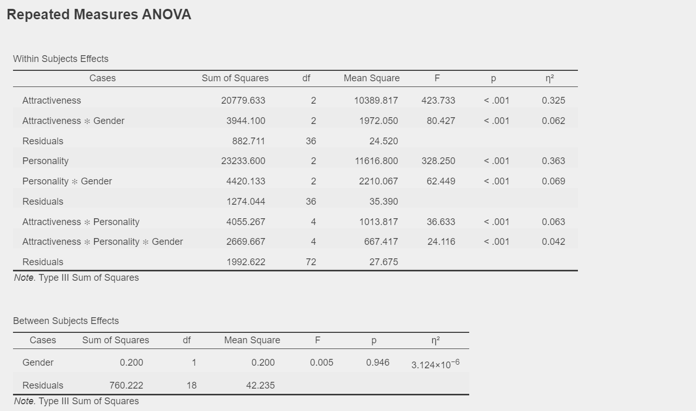

**ATTRACTIVENESS**

The main effect of Attractiveness is highly significant (F = 423.733, p < .001), explaining 32.5% of the variance in the data.

The interaction between Attractiveness and Gender is also significant (F = 80.427, p < .001), suggesting that the impact of Attractiveness varies by gender.

**PERSONALITY**

The main effect of Personality is strongly significant (F = 328.250, p < .001), accounting for 36.3% of the variance.

There is a significant interaction between Personality and Gender (F = 62.449, p < .001), indicating that the effect of Personality differs based on gender.

**Interaction between Attractiveness and Personality**

The interaction effect is significant (F = 36.633, p < .001), explaining 6.3% of the variance.

Additionally, the three-way interaction involving Gender is also significant (F = 24.116, p < .001), suggesting a nuanced interplay among Attractiveness, Personality, and Gender.

High and some attractiveness tend to result in higher mean scores for all personality types and genders compared to no attractiveness. In some cases, gender effects on mean scores are evident, suggesting possible interactions. Coefficients of variation highlight variation relative to the mean and provide context for interpreting results. The study and generalization may be limited by the relatively small sample size of each subgroup. Relying on self-rated measures of attractiveness and personality introduces subjectivity. The study does not take into account potential confounding variables that may affect the observed results.

POST HOC TESTS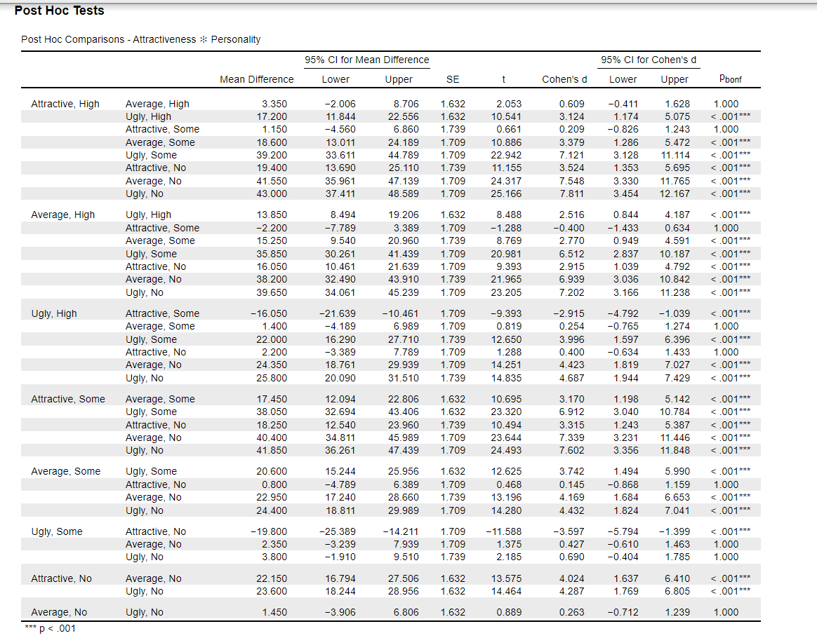

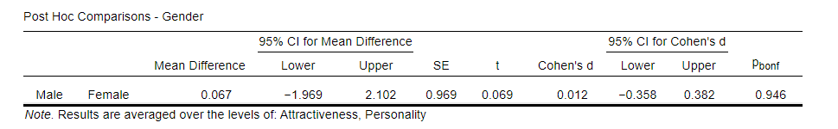

It is not statistically significant that there is a slight (0.067) mean difference between the male and female groups. There is no significant difference, as indicated by the fact that zero is included in the 95% confidence interval for the mean difference (-1.969 to 2.102). Cohen's d effect size is incredibly tiny (0.012), indicating that it has very little practical importance. Cohen's d has a 95% confidence interval that includes zero (-0.358 to 0.382), supporting the modest effect size. The absence of a meaningful difference is confirmed by the Bonferroni-corrected p-value of 0.946, which is not significant following multiple comparison adjustment.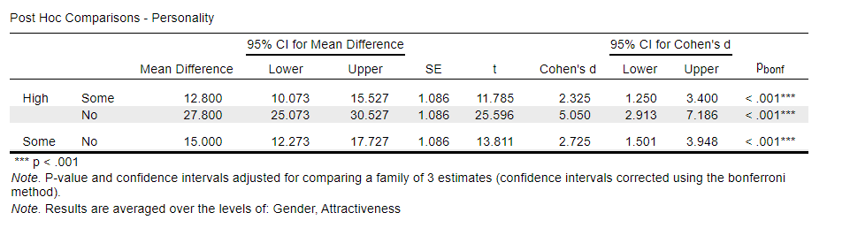

Following Bonferroni correction, all mean differences between the groups (High vs. Some, High vs. No, and Some vs. No) have p-values less than.001, indicating statistical significance. There are notable differences between the groups based on the 95% confidence intervals for the mean differences not included zero. The significant Cohen's d effect sizes imply a high practical significance for each comparison. The practical significance of the observed differences is further supported by the large and non-zero 95% confidence ranges for Cohen's d. Bonferroni-corrected p-values consider repeated comparisons, lowering the possibility of Type I errors.

TEST OF SPHERICITY

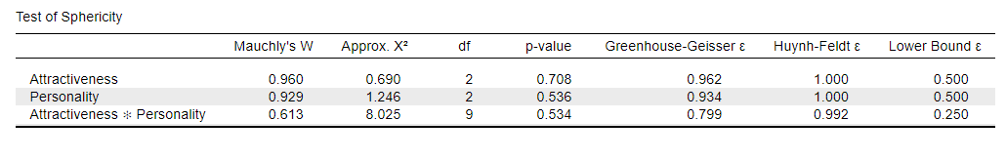

Mauchly's W values for Attractiveness, Personality, and their interaction show possible deviations from the sphericity assumption. For each of the three variables, the p-values for Mauchly's W indicate non-significant deviations from sphericity. Huynh-Feldt and Greenhouse-Geisser epsilon values were computed to account for possible sphericity violations. The confidence interval's bottom bound for the epsilon adjustment is represented by the bottom Bound.

Since there are no significant p-values for Mauchly's W, it seems possible that the sphericity assumption is not seriously broken. The trustworthiness of the ANOVA results is ensured by the Greenhouse-Geisser and Huynh-Feldt adjustments, which offer adjusted degrees of freedom to account for probable sphericity violations. The corrected degrees of freedom allow for a more precise interpretation of the ANOVA results by researchers.

Although changes were made, care should be taken when interpreting results, and researchers should be mindful of the assumptions underlying the analysis. The small sample size may impact the reliability of the sphericity test.

Distribution plots

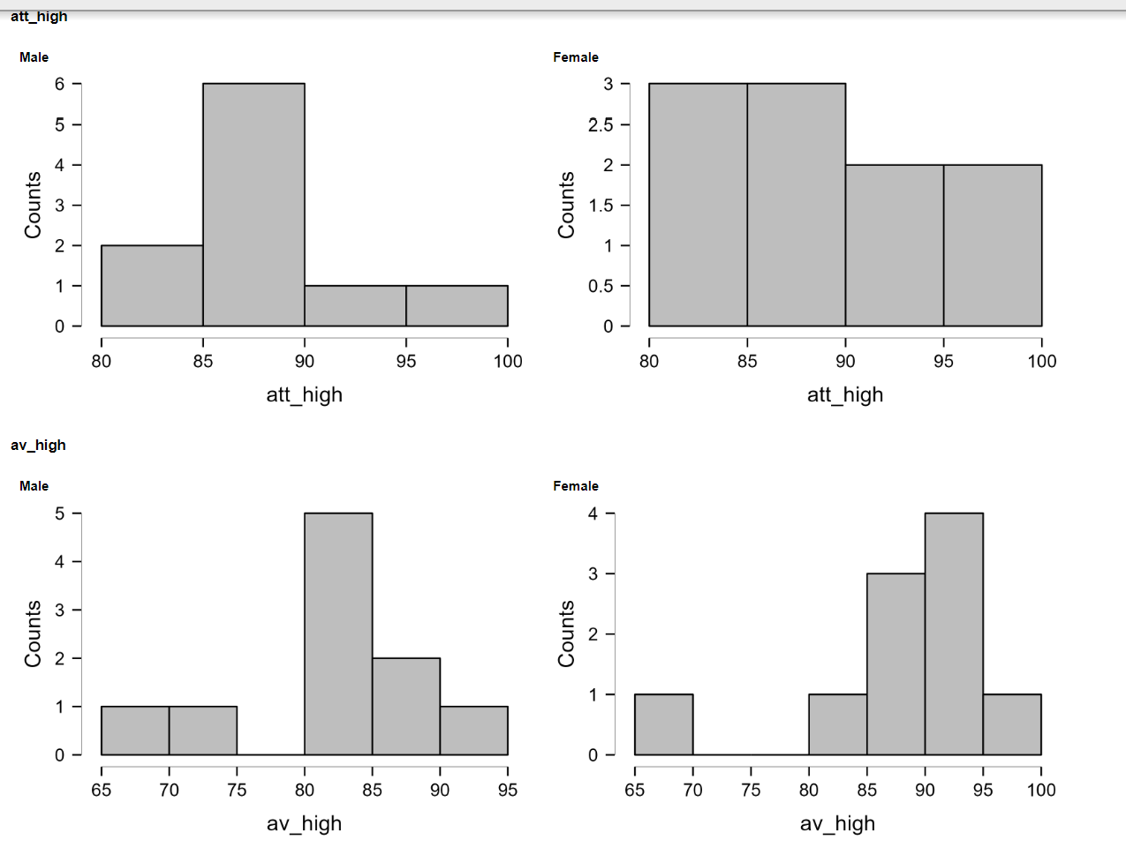

The research focused on RM Factor 1 and employed Repeated Measures ANOVA with Type III Sum of Squares to examine within-subject effects and interactions. The modest F-value (0.103) and high p-value (0.754) suggest that RM Factor 1 lacks a noticeable impact on within-subject effects. Apart from the gender interaction, which significantly influences within-subject effects, interactions with other factors are deemed inconsequential, supported by a low p-value (0.053) and a reasonably high F-value (4.680) indicating gender's impact on within-subject effects. Descriptive statistics reveal minimal gender differences in personality and appearance, with women slightly rating themselves higher. Post Hoc Tests underscore variations in mean appearance and personality traits by gender, emphasizing the importance of using confidence intervals and Pholm values for result evaluation. Acknowledging the study's limitations, notably the small sample size of 10 for each gender, is crucial for assessing the research's generalizability.